#### Data Source Name (DSN)

It is the name that applications use to request a connection to an ODBC Data Source. In other words, it is a symbolic name that represents the ODBC connection. It stores the connection details like database name, directory, database driver, UserID, password, etc. when making a connection to the ODBC.

Here are the various types of ODBC Data Source Types:

1. System DSN: This is the DSN used throughout the system, any with proper rights may log in. This DSN must be created on the machine where the program is located. The System DSN are stored in the Windows registry under the following key: HKEY_LOCAL_MACHINE\Software\Odbc\Odbc.ini\Odbc Data sources

2. User DSN: This is a DSN created for a specific user. Only the user who created the DSN can see this and use it. Like the System DSN, the information is stored in the Windows registry under the following key: HKEY_CURRENT_USER\Software\Odbc\Odbc.ini\Odbc Data sources

3. File DSN: This is a DSN that is stored in a text file with a .DSN extension (not in the Windows registry). To use a File DSN, it must contain the information required to connect to the desired data source. The ODBC driver must be installed locally. The .dsn file is a text file that you can view in any text editor, such as Microsoft Notepad. The File DSNs are stored by default in the following location:Program Files\Common Files\Odbc\Data Sources folder.

|  |  |
| --- | --- |
| **Setting Up an ODBC Data Source For MS Access** |  |

|  |  |  |
| --- | --- | --- |
|  | http://www.interfaceware.com/manual/images/note_icon.gif |  |
|  | This example shows you how to set up a new ODBC connection to an MS Access database. The steps and screenshots will be similar but slightly different when you set up other supported databases. |  |
|  |  |  |

To set up a new ODBC data source using MS Access:

* Click **Start** > **Settings** > **Control Panel** > **Administrative Tools** > **Data Sources (ODBC)**. The ODBC Data Source Administrator window appears.

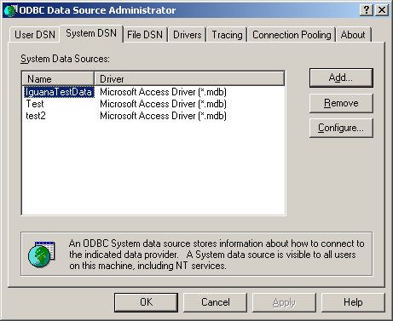

**ODBC Data Source Administrator Window**

* Click the **System DSN** tab, and click **Add** to create a new data source. The Create New Data Source window appears.

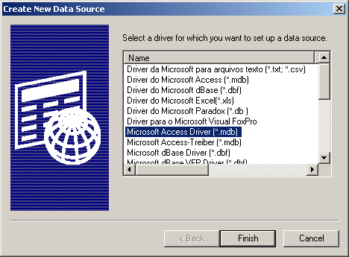

**Create New Data Source Window**

* Select **Microsoft Access Driver (*.mdb)** and click **Finish**. The ODBC Microsoft Access Setup window appears.

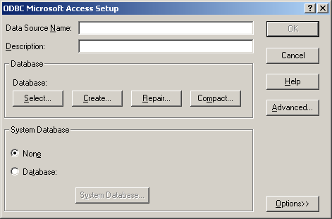

**ODBC Microsoft Access Setup Window**

* Enter the Data Source Name. In this example we created a data source called **TestChannel**.

|  |  |  |
| --- | --- | --- |
|  | http://www.interfaceware.com/manual/images/note_icon.gif |  |
|  | Alternatively, you can choose an existing database by using the **Select** button. In addition you can access and configure other parameters, such as the Login name and Password fields, by clicking the **Advanced** button. |  |
|  |  |  |

* **(Optional)** Enter a description of your data source.
* Under Database, click the **Create** button to create your database. The New Database window appears.

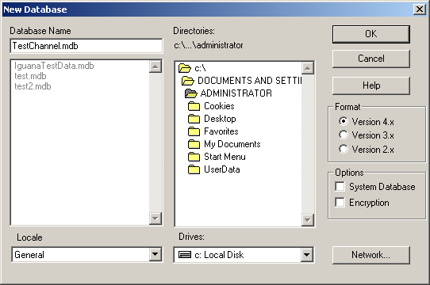

**New Database Window**

* Enter the Database Name (e.g. TestChannel.mdb).
* Choose where to save the database and click **OK**. A dialog window appears, confirming you have successfully created your database.
* Click **OK** to complete the data source setup. Your newly created database appears under System Data Sources as shown below.

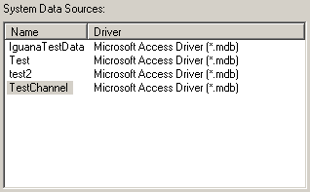

**System Data Sources**